**Question 1:** Prove that

1. (A+B)(A+CD) = A+BCD
2. X+XY = X
3. XY+XY’ = X
4. X+X’Y = X+Y
5. X(X+Y) = X
6. (X+Y)(X+Y’) = X
7. X(X’+Y) = XY

**Question 2:** Find complement of following function using **a)** DeMorgan’s Law **b)** Dual

F = X(Y’Z’+YZ)

**Question 3:** Represent the following sentence by a Boolean expression:

*“In a battery-powered computer, the disk drive motor 1 should be on if and only if*

1. *There is a disk in the drive, and*
2. *The disk drive is closed, and*
3. *The disk drive motor 2 is not on, and*
4. *The battery low signal is not present, and*
5. *The computer has started a read operation, or the computer has started a write operation.”*

**Question 4:** Perform the bitwise logic AND, OR, and XOR with the two 8-bit operands (5E)16 and (C5)16  and give the result in hexadecimal.

|  |  |  |
| --- | --- | --- |
| **OPERATION** | **Bit-Wise Result** | **HEXADECIMAL RESULT** |
| AND Operation |  |  |
| OR Operation |  |  |
| XOR Operation |  |  |

**Question 5:** Express F as a function of A, B, C and D.

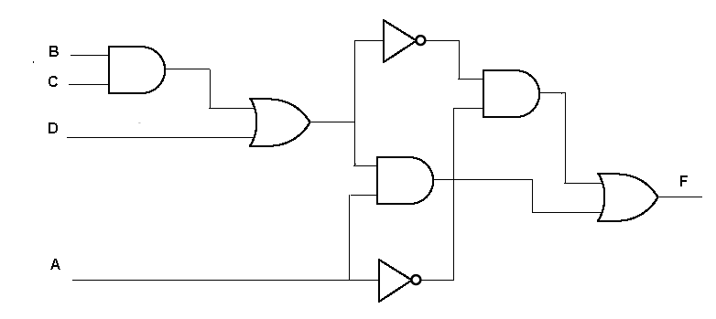

**Question 6:** Write the Boolean equations for the Circuits given below:

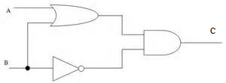



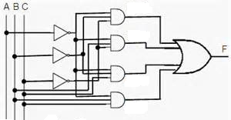

**Question 7:** Prove the following equation using truth table.



|  |  |  |  |  |  |  |  |  |  |  |  |
| --- | --- | --- | --- | --- | --- | --- | --- | --- | --- | --- | --- |
| *W* | *X* | *Y* | *Z* |  |  | *WZ* |  |  |  |  |  |
|  |  |  |  |  |  |  |  |  |  |  |  |
|  |  |  |  |  |  |  |  |  |  |  |  |
|  |  |  |  |  |  |  |  |  |  |  |  |
|  |  |  |  |  |  |  |  |  |  |  |  |
|  |  |  |  |  |  |  |  |  |  |  |  |
|  |  |  |  |  |  |  |  |  |  |  |  |
|  |  |  |  |  |  |  |  |  |  |  |  |
|  |  |  |  |  |  |  |  |  |  |  |  |
|  |  |  |  |  |  |  |  |  |  |  |  |
|  |  |  |  |  |  |  |  |  |  |  |  |
|  |  |  |  |  |  |  |  |  |  |  |  |
|  |  |  |  |  |  |  |  |  |  |  |  |
|  |  |  |  |  |  |  |  |  |  |  |  |
|  |  |  |  |  |  |  |  |  |  |  |  |
|  |  |  |  |  |  |  |  |  |  |  |  |
|  |  |  |  |  |  |  |  |  |  |  |  |

**Question 8:** Amna, Bilal and Rahim all are colleagues at work. Their work is to be divided in such a way that either only Amna works, or Bilal and Rahim work together and Amna does not work, or Amna and Bilal work together. Model this problem as a Boolean function, minimize it and implement it.

Exercises 2-1, 2-2, 2-3, 2-4, 2-6, 2-7, 2-8 and 2-9 from chapter 2 (Moris Mano 4th Edition).